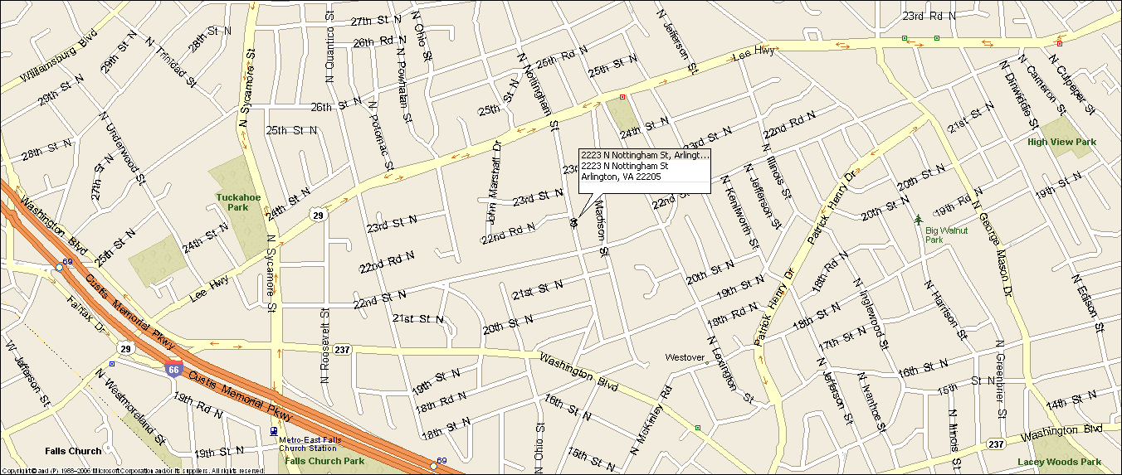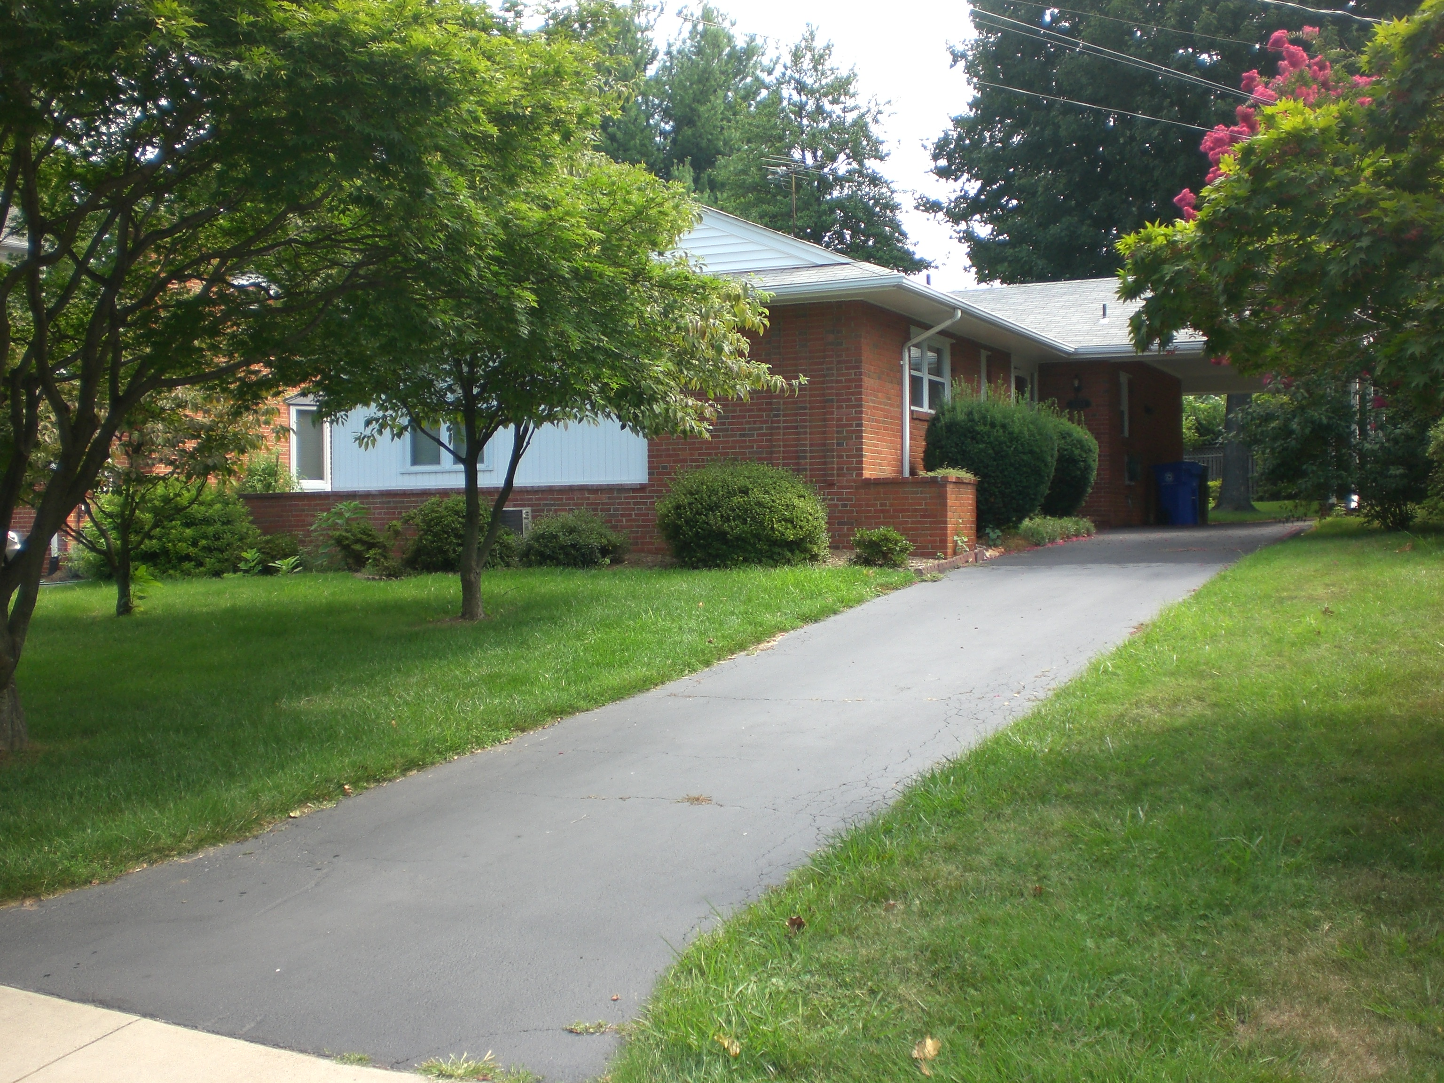
2223 N. Nottingham Street
Arlington, VA 22205
Classic Brick Rambler
Great location: Walk to EFC Metro & Westover Village & new Italian Deli, Close to DC (6 miles), Tysons Corner (6 miles), I-66, Rt. 29
- Five bedrooms, two full baths.
- Central a/c, natural gas heat & hot water.
- New kitchen w/ SS appliances & granite.
- Off street parking for 4 cars, carport.
- Large landscaped yard, great back yard.
- Original refinished hardwood floors thru out.
- New lower level carpet & paint.
- Established quiet, sought after neighborhood.
- Excellent Schools: Tuckahoe Elementary, Swanson MS, & Yorktown HS
- Lease terms: 1 year minimum, no smoking, no use of fire place.
RENT: $3,750.00 / month + utilities, contact Lyndsay Saffer 703-906-3082
Email: safferlyndsay@gmail.com

